
Competition copy
[Insert date]
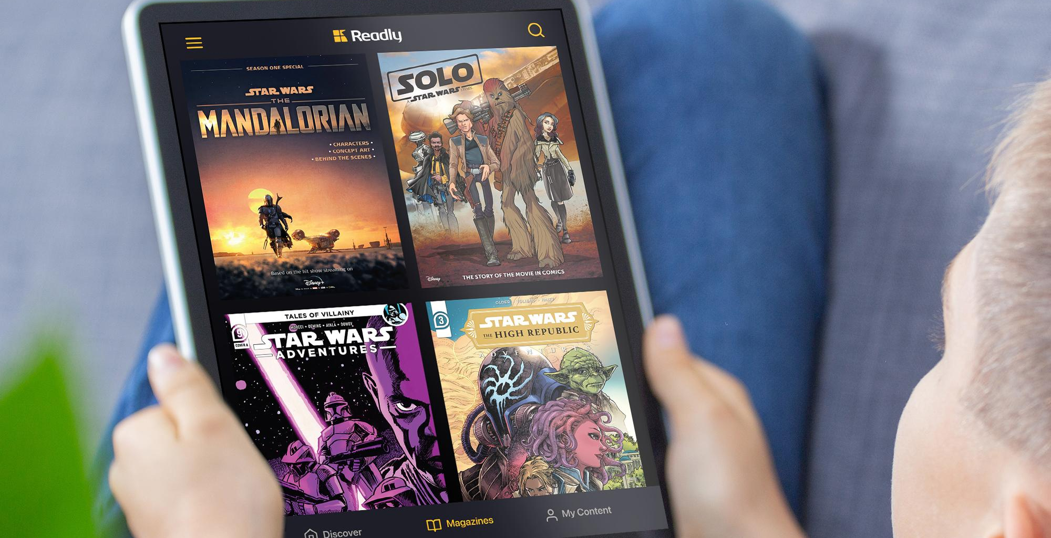
May the fourth be with you: Readly celebrates International Star Wars™ Day
Readly, the digital magazine and newspaper app features a fantastic portfolio of Star Wars magazines to help fans celebrate their love of Star Wars on May 4th and beyond.
Fans will delight in reading their top titles, alongside the huge breadth of digital magazines and newspapers available on the Readly app. With much-loved titles such as Star Wars Adventures, Star Wars Graphic Novels and Star Wars My First Comics, Star Wars fans young and old can immerse themselves in all the fantasy and adventure of Star Wars. Plus Readly gives unlimited reading to over 7,000 magazines and newspapers via your smartphone, tablet or laptop.
Readly collaborated with Disney to bring the Star Wars titles onto its app last year with over 80 Disney magazines and comics. It is the perfect app for inspiring all the family to read more at home and on the go.

From science-fiction, history, sport, news and music, there is a magazine for all the family to read. And as a Readly subscription gives users five profiles per household, the whole family can enjoy reading too!

To celebrate Star Wars Day, grab a subscription for £9.99 per month at: www.readly.com

© & TM Lucasfilm Ltd.



